**Recognition of facial patterns for pain scale assessment: A prospective study for neonatal monitoring at NICU**

**Abstract-** The objective of this study is to monitor the neonates at NICU and detect the pain, discomfort experienced by the baby from facial expression analysis. In this context a few papers have been reviewed which deals with different methods of facial expression detection and classification. The clinical applications are also described with respect to pre-term babies, full-term babies, toddlers and infants. The processing methods are reviewed which includes different methods of data acquisition, feature extraction and classification. This motivates us to design new method of wireless neonatal monitoring in real-time and detects the pain / discomfort experienced by babies. It also aims at estimating sleep wake cycles of the babies.

**Introduction-** New-born babies who need intensive medical care are often put in a special area of the hospital called the neonatal intensive care unit (NICU). Babies which are born preterm or with any health disorders are placed in NICU to provide special care and monitor continuously. Newborn infants are exposed to painful experiences that might increase their short- and long-term morbidity and mortality, in addition to being associated with neurological developmental disorders.[1] Preterm birth is when an infant is born too early, before 37 weeks of gestation .Preterm infants receive special care in the neonatal intensive care unit (NICU), where their vital signs are continuously monitored. Based on statistics for 184 countries, the global average preterm birth rate in 2010 was 11.1%, giving a worldwide total of 14.9 million infants [2]. More than 15 million premature infants are born worldwide each year. These infants, along with term neonates who are born ill, compromised either by congenital abnormalities or by peripartum or intrauterine adverse events, spend their first weeks of life hospitalized in the neonatal intensive care unit (NICU) where they are subjected to multiple invasive procedures that are frequently painful. It has been reported that hospitalized infants born at 25 to 42 weeks gestation experienced an average of 14 painful procedures a day during the first 2 weeks of life. In addition, many newborns, both premature and term, undergo surgical procedures associated with postoperative pain. Pain is an unpleasant sensory and emotional experience associated with actual or potential tissue damage[3].

Patients in the NICU are unstable and have fluctuating vital signs. To monitor their physiological status, specialised medical equipment is used depending on their unique needs. The standard vital signs monitored usually include heart rate (HR), respiratory rate (RR), blood pressure, temperature and peripheral oxygen saturation (SpO2). A very low or high heart rate can indicate an underlying condition such as infection, pain or illness.[4] Facial expression analysis provides valid, highly sensitive and specific information on the nature and intensity of pain, thus allowing for efficacious communication between newborn infants and neonatal healthcare providers [1]. Over the use of nociceptive stimulus in adults , analysis of judgements by diverse observers validation of facial expression of pain.[5]

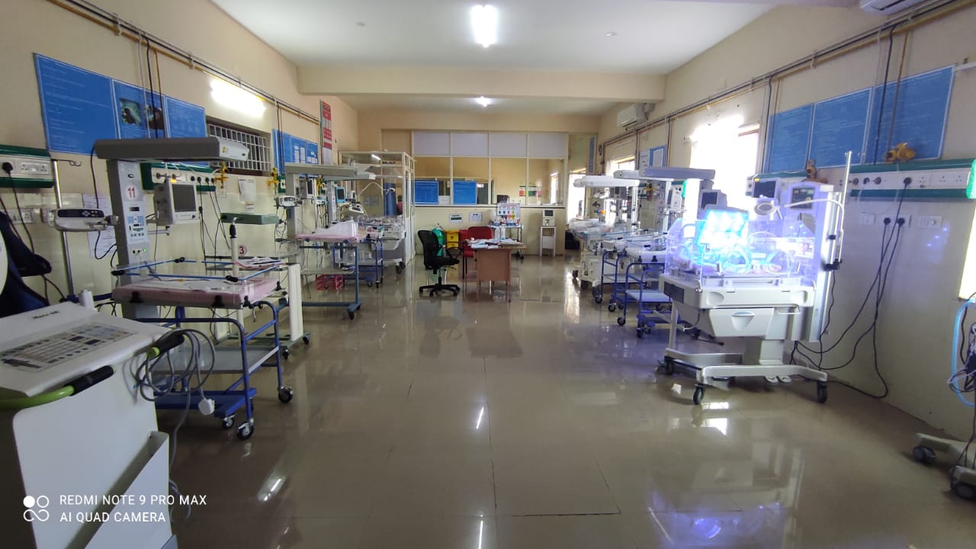

**Figure 1 NICU setup**

**Figure 2 Infant warmer**

**Importance of Pain scale assessment and management**

Pain is an unpleasant sensory and emotional experience associated with actual or potential tissue damage. The inability to communicate verbally does not negate the possibility that an individual is experiencing pain and is in need of appropriate pain-relieving treatment. this requires caregivers to be knowledgeable about and to implement the most valid and reliable pain assessment tools to optimize pain management in neonates. Accurate assessment of pain is vital to ensure the optimal effectiveness and safety of pain management therapy in neonates who experience pain during the course of their NICU stay.[3].

Accurate pain measurements in children are difficult to achieve. Three main methods are currently used to measure pain intensity: self-report, behavioral, and physiological measures. The most common pain measures used for infants are behavioral. These measures include crying, facial expressions, body posture, and movements. The quality of these behaviors depends on the infant’s gestational age, and maturity. Preterm or acutely ill infants, for example, do not illicit similar responses to pain due to illness and lack of energy. In addition, interpretation of crying in infants is especially difficult as it may indicate general distress rather than pain. Cry characteristics are also not good indicators in preterm or acutely ill infants, as it is difficult for them to produce a robust cry[6].

The Joint Commission standards for hospitalized patients make pain assessments mandatory for all patients. The standard numeric 0–10 pain scale may be useful in verbal children; however, there are scales that have been validated for use in children as young as three for pain reporting. The revised FACES pain scale, the Wong-Baker Faces scale, and the 10-cm visual analog scale are used in many healthcare settings to assess a pediatric patient’s pain. Assessment of pain by physiologic parameters in the neonatal population are validated pain multiple scales like: the neonatal infant pain scale (NIPS); neonatal facial coding system (NFCS); neonatal pain, agitation, and sedation scale(N-PASS); cry, required oxygen, increased vital signs, expression, sleeplessness scale (CRIES); COMFORT Scale; and DouleurAigue Nouveau-ne (DAN) scoring system. The premature infant pain profile (PIPP) is a validated pain scoring system for preterm neonates. For infants, non-verbal young children, and in patients with cognitive impairment, the face, legs, activity, crying, and consolability (FLACC) scale or the revised FLACC scale can be used[7].

**Table 1 Summary of neonatal pain scales**

|  |  |  |  |
| --- | --- | --- | --- |
| **Pain scale** | **What variables are included?** | **Type of pain** | **Notes** |
| PIPP (premature infant pain  profile) | Heart rate, oxygen saturation, facial actions | Procedural,  postoperative | Reliable, valid, clinical utility is  well established |
| NIPS (neonatal infant pain  score) | Facial expression, crying, breathing  patterns, arm and leg movements, arousal | Procedural | Reliable, valid |
| NFCS (neonatal facial coding  system) | Facial actions | Procedural | Reliable, valid, clinical utility is  well established, high degree of  sensitivity to analgesia |
| N-PASS (neonatal pain,  agitation and sedation scale) | Crying, irritability, facial expression,  extremity tone, vital signs | Procedural,  postoperative,  mechanically  ventilated patients | Reliable, valid. Includes sedation  end of scale, does not distinguish  pain from agitation |
| CRIES (cry, requires oxygen,  increased vital signs,  expression, sleeplessness) | Crying, facial expression, sleeplessness,  requires oxygen to stay at 95 %  saturation, increased vital signs | Postoperative | reliable, valid |
| COMFORT scale | Movement, calmness, facial tension,  alertness, respiration rate, muscle tone,  heart rate, blood pressure | Postoperative, critical  care | Reliable, valid, clinical utility well  established |
| DAN (DouleurAigue¨ du  Nouveau-ne´) | Facial expression, limb movements, vocal  expression | Procedural | Reliable, valid |

**Figure 3 NFCS pain assessment tool**

**Figure 4 NIPS pain assessment tool**

**Facial pattern recognition and its importance**

Facial expressions are one of the most important stimuli when interpreting social interaction, as they provide information on the identity of the person and on his emotional state. Facial emotions are one of the most important signal systems when expressing to other people what happens to human beings. The automatic recognition of facial expressions could be a great advance in the field of health, in applications such as pain detection in people unable to communicate verbally, decreasing the continuous monitoring by medical staff. Babies are one of the biggest groups that cannot express pain verbally, so this impossibility has created the necessity of using other media for its evaluation and detection. In this way, pain scales based on vital signals and facial changes have been created to evaluate the pain of neonates.[8]. Analysis of these expressions are mainly based on facial features or landmarks are statistically related with pain stimulus. This further led to the development of multi-dimensional scoring systems which combines both facial expressions and physiological parameters statistically on application of pain stimulus.

Facial expression recognition (FER) has always been a challenging topic in computer vision. Researchers usually aim to build a system that can identify different expressions in the images automatically. Research on facial expression recognition relies heavily on an adequate dataset of facial expressions. However, due to the inherent nature of facial expressions and the difficulty of obtaining them, there are currently only a limited number of publicly available databases, which provide a sufficient number of facial images and are tagged with accurate facial expression information.[9]

**Table 2 Overview of the existing facial expression datasets as reported by Qing Lin et.al[9]**

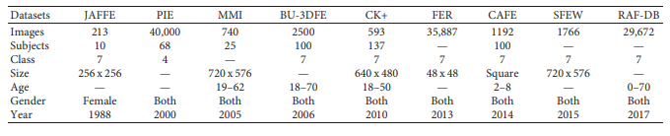

Extended Newborns Face Database, Children Multimodal Biometric Database (CMBD)[10] -WIDERFACE dataset [11] Hanindito dataset [12], BabyExp dataset [9]also reported by authors.

Facial expressions are considered the gold standard in pain assessment because they are the most specific and frequent indicators of pain. The facial characteristics associated with pain in infants include prominent forehead, eye squeeze, naso-labial furrow, taut tongue, and an angular opening of the mouth. Unlike facial behaviors, body movement and crying are less specific indicators of pain, as they are associated with other states, such as hunger, fright and discomfort. most pain instruments developed for infants, toddlers and older children, including COMFORT, CRIES , FLACC (Face, Legs, Activity, Cry, Consolability) , MIPS (Modified Infant Pain Scale) , CFACS (Child Facial Coding System) and NFCS (Neonatal Facial Coding System) [rely in whole or in part on facial displays.[13].

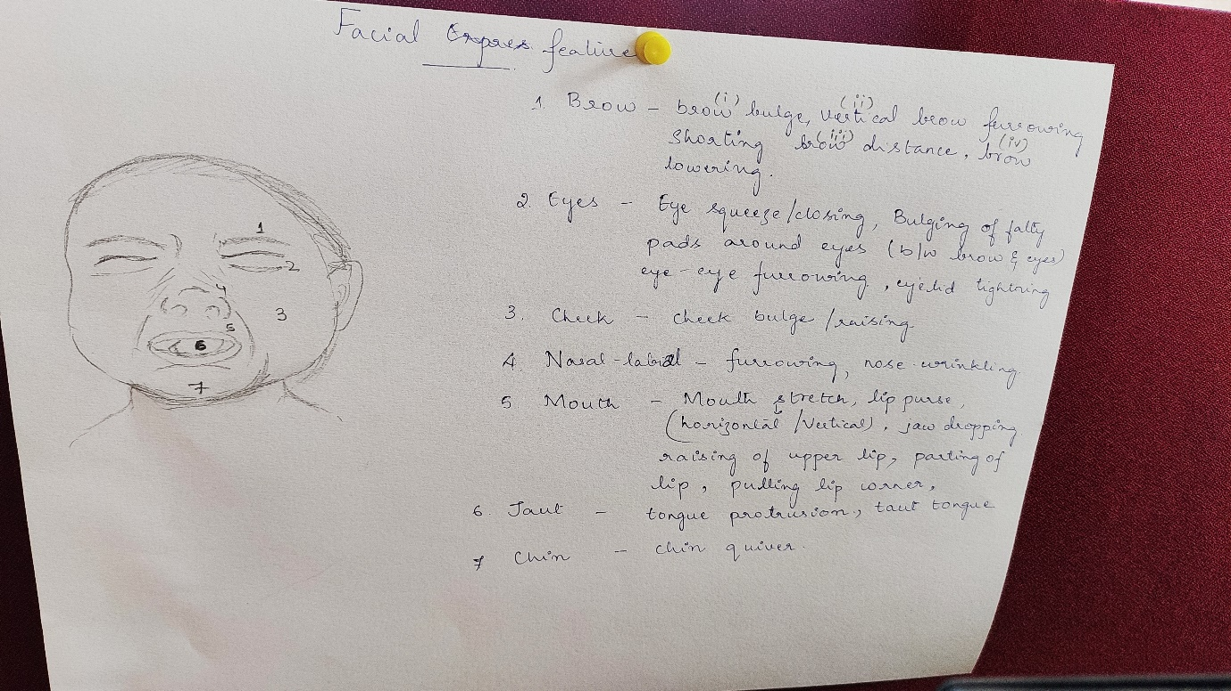

**Figure 5 Facial features**

Feature extraction methods of facial expressions can be divided depending on their approach. Generally speaking, features are extracted from facial deformation, which is characterized by changes in shape and texture, and from facial motion, which is characterized by either the speed and direction of movement or deformations in the face image .[8] The method of discomfort detection involves 2 key steps: (1) face detection and face normalization, and (2) feature extraction, and facial expression classification to discriminate infant status into comfort or discomfort.[2]

Various machine assessment system of neonatal expressions of pain be developed to assist health professionals in diagnosing pain which includes learning-based feature extraction algorithms like, Principal Component Analysis (PCA), Linear Discriminant Analysis (LDA)[10][8], Local Ternary Patterns(LBP) [8] ,Texture Algorithm like Local Binary Patterns(LBP)[10][2], Histogram of Oriented Gradients (HOG)[2], Deep Learning algorithms Fine-tuned VGG Face, Triplet Convolutional Neural Network (Triplet CNN) [10], Feature Guided CNN [9] Geometrical feature detection algorithms like Point Pair Analysis[14][15], AAM(Active Appearance Model)[16][12], Active Shape Model (ASM)[12][17] and Deep learning classification algorithms like Support Vector Machines (SVMs)[13][8][12][18][16] [17] ,k-Nearest Neighbors (kNN)[18] and Neural Networks[18][4] are reported. Few works which uses morphological processing methods are also reported[19][20].

**Challenges and opportunities**

When choosing specific scales to use for neonatal pain, it is always important to select scales that have been proven validated and reliable. There are many challenges in selecting appropriate scales for a given NICU setting. This is because NICU populations are diverse, often made up of premature and term infants; some sedated, paralyzed, and mechanically ventilated infants; and some postsurgical infants. If a given scale relies on an audible cry for assessment, then this scale may not be useable for a sizable portion of the population. As noted previously and in Table1, scales may have demonstrated validity and reliability only for a certain gestational age and a certain type of pain, which makes selecting a single scale for entire NICU population very difficult. Practical considerations also must be factored into scale choice.



**Block Diagram of proposed study**

**Conclusion and Proposed method**- The review describes various methods to detect facial expressions and classify them accordingly. This motivates us to develop a an automated wireless system which monitors babies at NICU in real-time and an algorithm is designed such that it automatically detects pain / discomfort/ hunger experienced by babies and alerts the caregivers or doctors. It also estimates sleep wake cycle of the infants based on hands and leg movements. This helps in better diagnosis and neonatal monitoring.

References

[1] T. M. Heiderich, A. Teresa, F. Stochero, and R. Guinsburg, “Neonatal procedural pain can be assessed by computer software that has good sensitivity and specificity to detect facial movements,” pp. 63–69, 2015, doi: 10.1111/apa.12861.

[2] Y. Sun *et al.*, “Video-based discomfort detection for infants,” *Mach. Vis. Appl.*, vol. 30, no. 5, pp. 933–944, 2019, doi: 10.1007/s00138-018-0968-1.

[3] L. G. Maxwell, M. V Fraga, and C. P. Malavolta, “Assessment of Pain in the N e w b o r n : An Update Neonate Pain Assessment Pain scales,” vol. 46, pp. 693–707, 2019, doi: 10.1016/j.clp.2019.08.005.

[4] M. Villarroel *et al.*, “Non-contact physiological monitoring of preterm infants in the Neonatal Intensive Care Unit,” *npj Digit. Med.*, vol. 2, no. 1, pp. 1–18, 2019, doi: 10.1038/s41746-019-0199-5.

[5] R. De Ca, R. Guinsburg, M. Fernanda, B. De Almeida, M. H. Miyoshi, and B. I. Kopelman, “The Recognition of Facial Expression of Pain in Full-Term Newborns by Parents and Health Professionals,” vol. 154, pp. 1009–1016, 2000.

[6] R. Srouji, S. Ratnapalan, and S. Schneeweiss, “Pain in Children : Assessment and Nonpharmacological Management,” vol. 2010, 2010, doi: 10.1155/2010/474838.

[7] N. Witt, S. Coynor, C. Edwards, and H. Bradshaw, “A Guide to Pain Assessment and Management in the Neonate,” *Curr. Emerg. Hosp. Med. Rep.*, vol. 4, no. 1, pp. 1–10, 2016, doi: 10.1007/s40138-016-0089-y.

[8] A. Martínez, F. A. Pujol, and H. Mora, “Application of texture descriptors to facial emotion recognition in infants,” *Appl. Sci.*, vol. 10, no. 3, 2020, doi: 10.3390/app10031115.

[9] Q. Lin, R. He, and P. Jiang, “Feature guided CNN for baby’s facial expression recognition,” *Complexity*, vol. 2020, pp. 0–2, 2020, doi: 10.1155/2020/8855885.

[10] S. Siddiqui, M. Vatsa, and R. Singh, “Face Recognition for Newborns, Toddlers, and Pre-School Children: A Deep Learning Approach,” *Proc. - Int. Conf. Pattern Recognit.*, vol. 2018-Augus, pp. 3156–3161, 2018, doi: 10.1109/ICPR.2018.8545742.

[11] C. Y. Chang and F. R. Chen, “Application of deep learning for infant vomiting and crying detection,” *Proc. - 32nd IEEE Int. Conf. Adv. Inf. Netw. Appl. Work. WAINA 2018*, vol. 2018-Janua, pp. 633–635, 2018, doi: 10.1109/WAINA.2018.00158.

[12] Y. Kristian *et al.*, “A Novel Approach on Infant Facial Pain Classification using Multi Stage Classifier and Geometrical-Textural Features Combination,” no. February, 2017.

[13] S. Brahnam, C. Chuang, R. S. Sexton, and F. Y. Shih, “Machine assessment of neonatal facial expressions of acute pain,” vol. 43, pp. 1242–1254, 2007, doi: 10.1016/j.dss.2006.02.004.

[14] M. Schiavenato and C. L. Von Baeyer, “A quantitative examination of extreme facial pain expression in neonates: The primal face of pain across time,” *Pain Res. Treat.*, vol. 2012, 2012, doi: 10.1155/2012/251625.

[15] M. C. Kirana, I. K. E. Purnama, Y. K. Suprapto, M. Hariadi, and M. H. Purnomo, “Facial feature extraction on pre and post-operative infant with NFCS and nCRF,” *Proc. 2013 3rd Int. Conf. Instrumentation, Commun. Inf. Technol., Biomed. Eng. Sci. Technol. Improv. Heal. Safety, Environ., ICICI-BME 2013*, pp. 54–58, 2013, doi: 10.1109/ICICI-BME.2013.6698464.

[16] E. Fotiadou, S. Zinger, W. E. Tjon, S. B. Oetomo, and P. H. N. De With, “Video-based facial discomfort analysis for infants,” vol. 9029, pp. 1–14, 2014, doi: 10.1117/12.2037661.

[17] R. Zhi, G. Zamzmi, D. Goldgof, T. Ashmeade, and Y. Sun, “Automatic Infants ’ Pain Assessment by Dynamic Facial Representation : Effects of Profile View , Gestational Age , Gender , and Race,” pp. 1–16, doi: 10.3390/jcm7070173.

[18] L. Hazelhoff and J. Han, “Behavioral State Detection of Newborns Based,” pp. 698–709, 2009.

[19] L. Wenping, L. Min, H. Wenfei, and L. Yu, “A Facial Expression Recognition Method for Baby Video Surveillance,” *Proc. 3rd Int. Conf. Multimed. Technol.*, vol. 84, pp. 516–523, 2013, doi: 10.2991/icmt-13.2013.63.

[20] jeetu, “F5131086617,” no. 6, pp. 101–106, 2017.